KEYNSHAM CHIPATA SOUTH PARISH LINK
TEACHER EXCHANGE - 2024

The background:
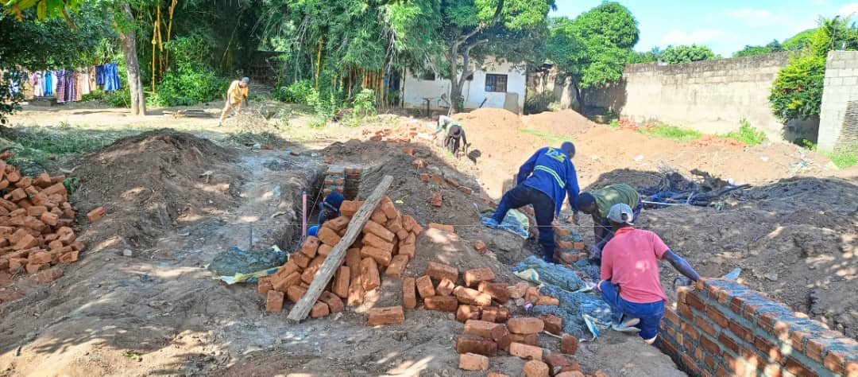
The friendship Link between the parishes of Chipata South in Eastern Zambia and Keynsham began in 2018. Since then, the friendship between the churches has grown through prayer, a well-used WhatsApp link and even face to face visits. We helped fund the building of a new Parish School in Chipata. It opened in 2021 and has gradually grown with over 100 pupils on the role and plans to build more classrooms.

The Schools Link:
In 2022, letter exchanges began between pupils at Chipata Parish School and St Johns and Two Rivers School (the two CE primary schools in Keynsham). Encouraged by the teachers, children have been finding out more about their Zambian friends, and even met the parish priest, Fr Benard Phiri, in February. The three schools are joining the Diocesan Zambia School Link scheme, to formalise their connection.

The Teacher Exchange April 2024:
Our next joint project is to host two Chipata teachers during April 2024. Their programme will include spending time in both schools and creating a joint programme of work. It will be an enriching experience for the Zambian teachers and for the Keynsham pupils, bringing to life the idea of ‘global citizenship’ in the best possible way.
For more information about the teacher exchange programme please contact Claire Formby, email clairevf9@gmail.com
How can you help?

HOSPITALITY
- transport whilst in UK
- overnight accommodation
- meals
- leisure activities/local visits

Please contact Rachel Shaw for more details and offers of help.
Email rachrishaw@gmail.com
Phone 0117 9868638

ZAMBIA- KEYNSHAM TRAVEL COSTS

On current costs, we estimate that these will amount to at least £2,500
*2 return flights Lilongwe - London *2 trips to Lusaka to arrange visas
*Visa costs *car travel Lilongwe - Chipata
Obviously, prices may change.

At this stage we are looking for pledges of financial support, so that we know how we stand for purchasing tickets and can start the process of visa applications. Actual payment will be needed nearer the time.

Please contact Rachel Shaw for a confidential discussion about promising a donation.
Email rachrishaw@gmail.com
phone 0117 9868638

Thank you
Keynsham Parish Zambia Action Group
Rachel Shaw, Anika Gardiner, Sue Sprague, Pip Traynar,
Wendy Harwood, Elhana Derrick, Claire Lowe, Gillian Watkins

